

**PROJECT REPORT**

**Parallel Sudoku Solver**

Course:

* Parallel & Distributed Computing.

Instructor:

* Dr. Nausheen Shoaib

Group Members:

* Syed ahzam imam 20k-1612
* Sharjeel ahmed 20k-0288

Objective:

Parallel programming using OpenMP for Parallel and Distributed Computing course. For this purpose, we have developed a serial and a parallel implementation of solving a Sudoku efficiently in less time. We have executed the program on a docker environment per the project’s requirement.

Methodology:

The grid consists of a matrix of size n x n, which is partially filled, and the algorithm fills the matrix cells, which are blank, with values from 1 to n in such a way that no value is repeated more than once on each of n columns and n rows or n squares of size√n × √n on which the matrix is split.

Output:

Comparison of Serial and Parallel

Docker image:

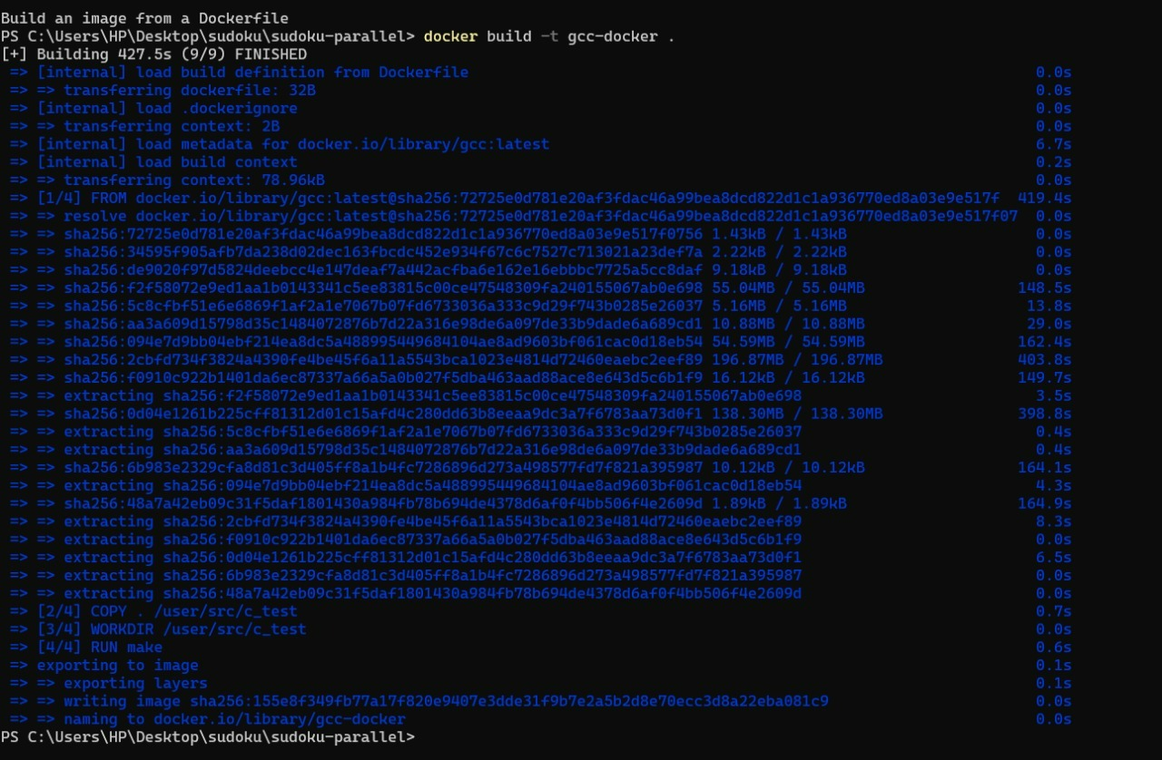

on input file 1

Threads: 4

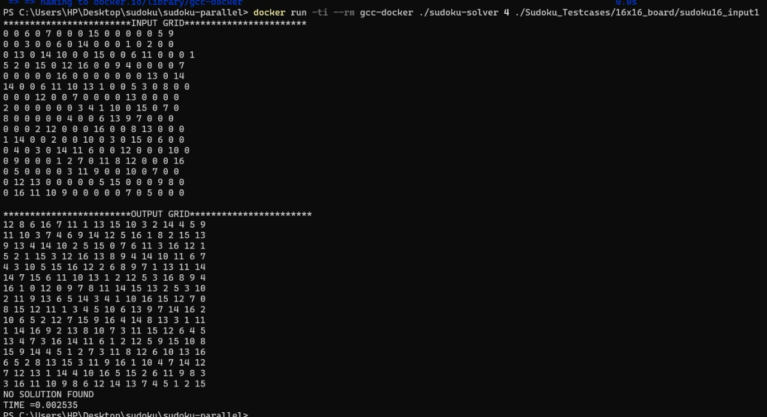

Threads: 2

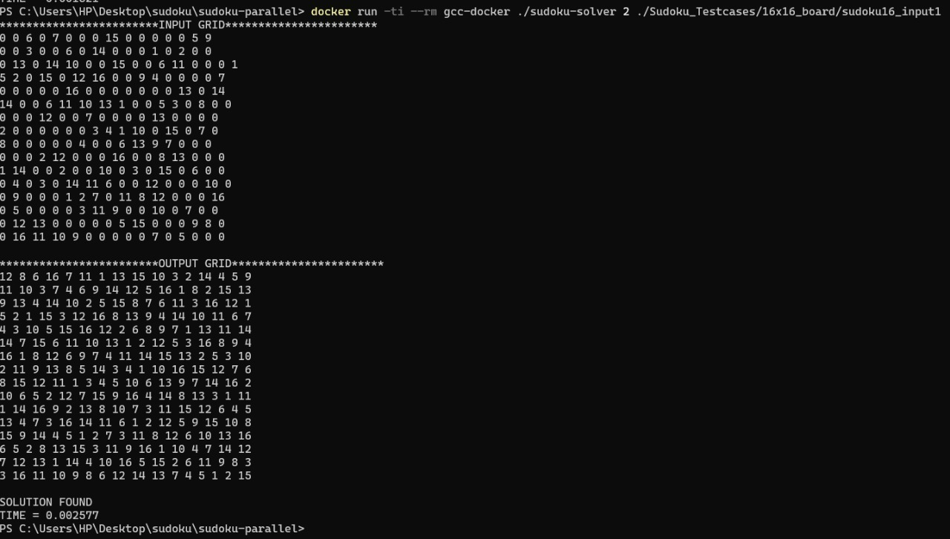

on input file

threads: 4

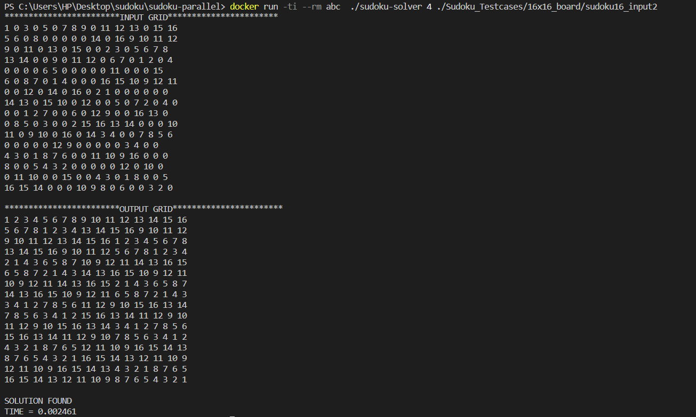

threads: 2

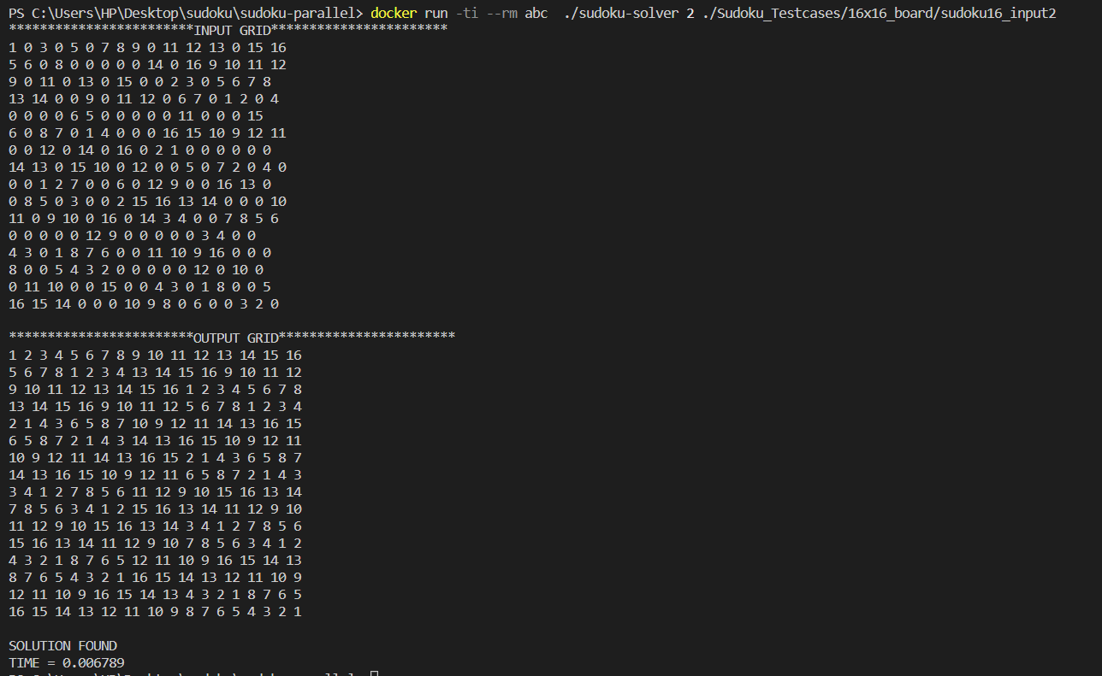

on input file 3

threads: 4

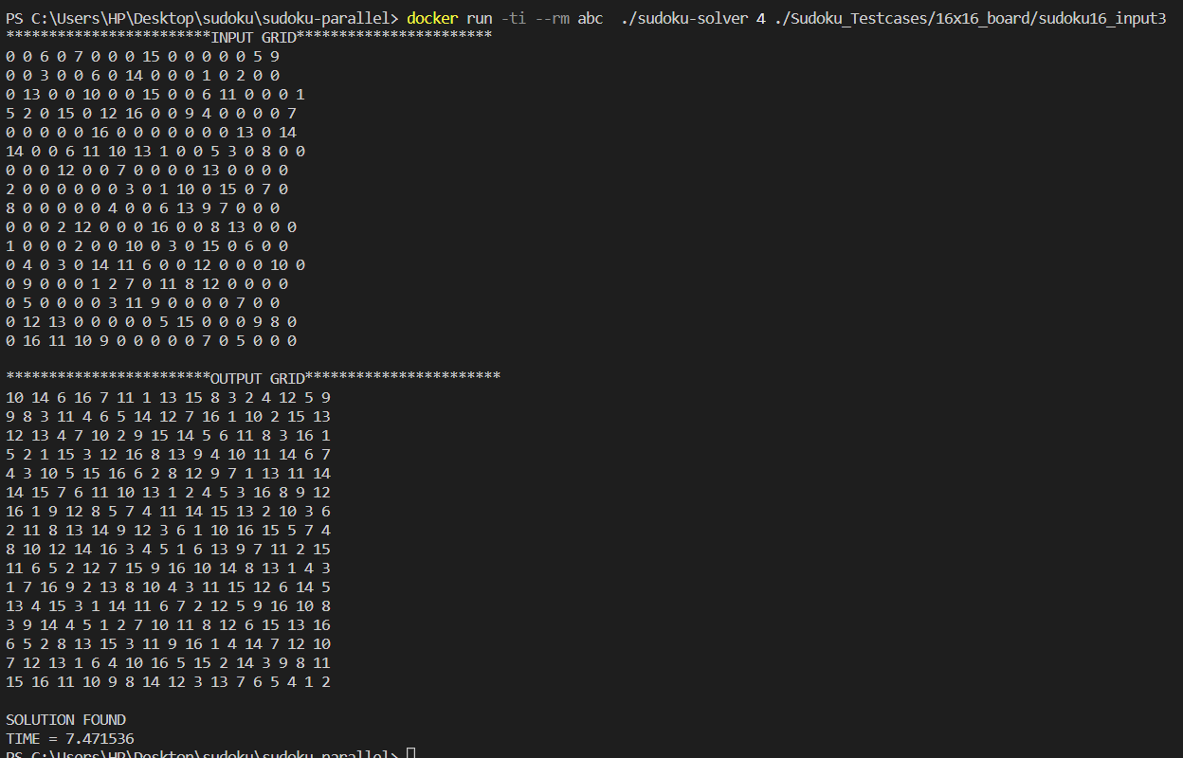

threads: 2

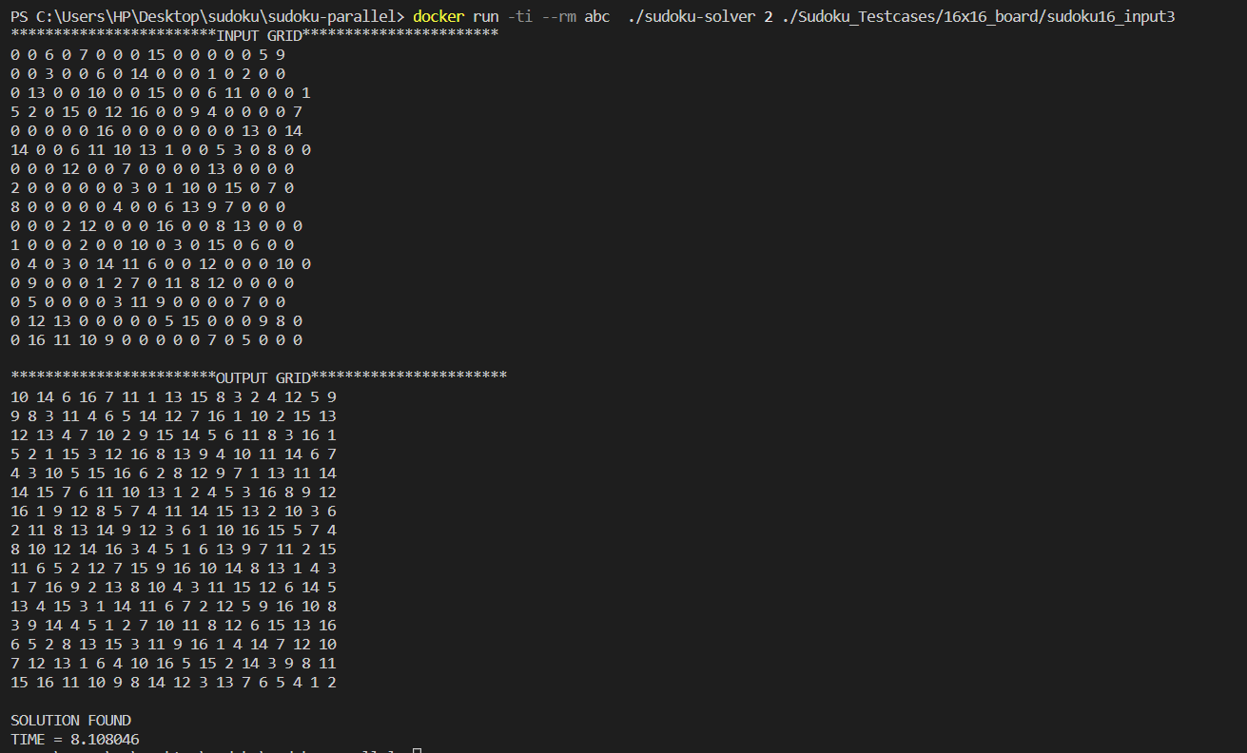

Serial:

Docker image:

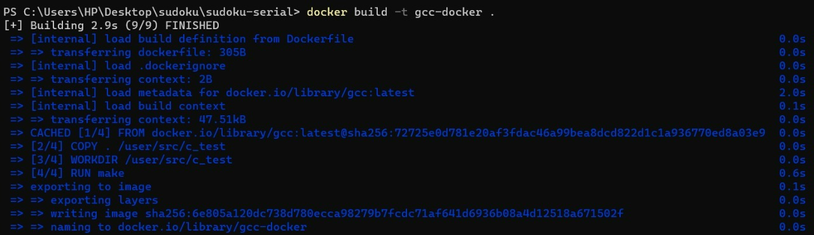

on input file 1

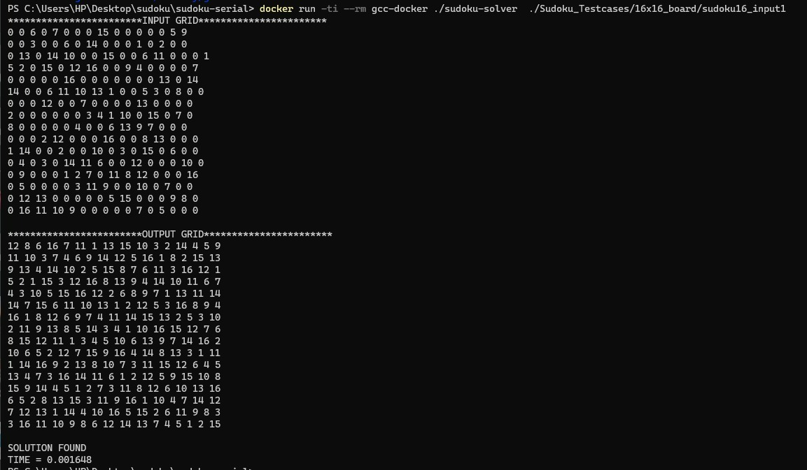

on input file 2

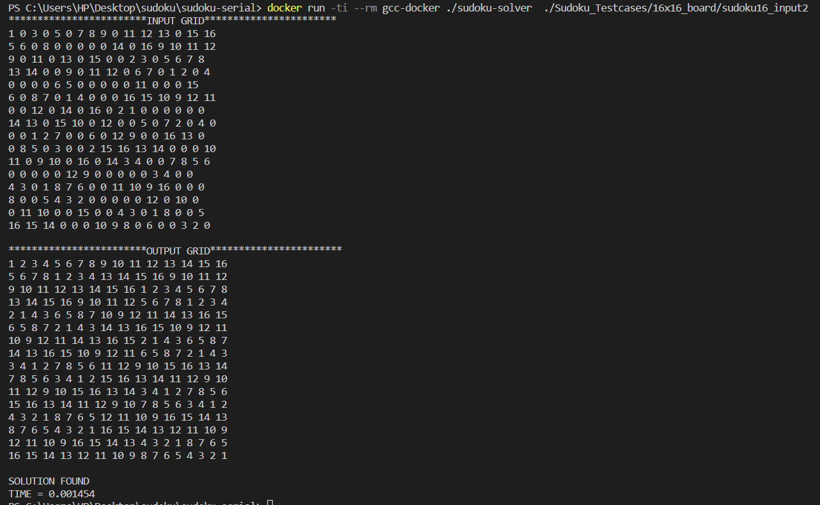

on input file 3

